Best DPI Resolution When Scanning Different Size Photos

Find out what DPI to use when scanning photos

In this article you’re going to learn...
- How to setup your scanner software and pick your DPI
- That 300 DPI is good enough for HDTV quality and 4" x 6" digital images
- That you'll need more DPI if you want to turn any size photograph and make it 2 times, 3 times, 10 times bigger!
If you're not sure how resolution works, then you might waste time scanning low quality images.... or waste time scanning images way too big for your needs.
Here's what you need to know...

1. How To Pick Your Resolution For Photo Scanning
Fire up you scanner, and look at your settings for "Resolution". Here's how mine looks like...
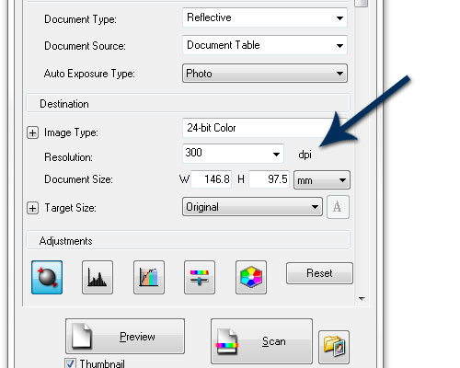
Simply input your DPI (dots per inch or PPI, pixels per inch).

2. Here's What Happens When You Scan A 4" x 6" Photo At 300 DPI
So what DPI do you use? Well, let's have a look at 300 DPI...
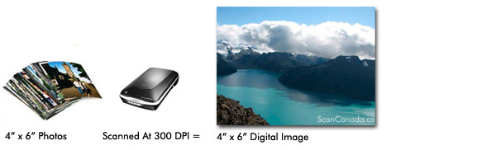
At 300 DPI you turn your 4x6 photo into the same size: 4x6 digital image. That's because when your photos were printed in the photo lab, they use 300 dots per inch to print your photo. So at 300 DPI, you're getting an exact copy of your original photo.
And, a 4x6 photo scanned at 300 DPI will be HDTV quality...
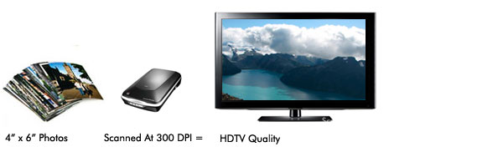
You can watch your 300 DPI photo scans as full resolution, HDTV quality images.

3. What Happens When We Scan A 4" x 6" Photo At 600 DPI Or More!
Now let's double the DPI to 600. Here's what happens...
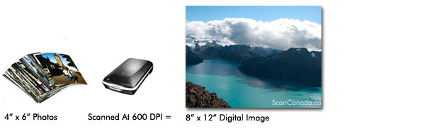
At 600 DPI you DOUBLED the size of your original photo. Your scanner mathematically figured out how to take your 4x6 photo, and make it into a 8x12 photo WITHOUT losing quality. This means you can take your 600 DPI photo scan into a print shop and re-print it at 8x12.
And at 900 DPI? The same thing...
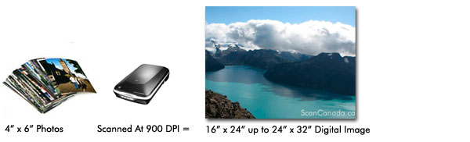
At 900 DPI you you'll get a 16" x 24" digital photo. You can even get away with 24" x 32".

4. What If You're Scanning Photos That Are Not 4" x 6"
Let's say you have those old 2" x 3" photos. Now, remember, if you use 300 DPI you'll get the exact same size...
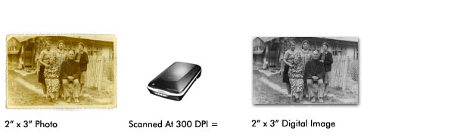
As you can see, 300 DPI will give you the SAME image.
Let's see what happens when I use 1200 DPI?
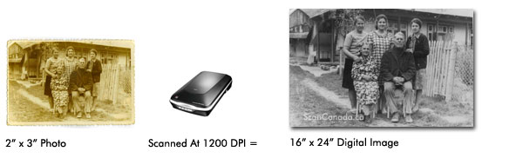
At 1200 DPI, you turned your tiny 2x3 photo into a 16x24 digital image -- without losing any quality.

3 Actions Steps To Help You Decide What's The Best Resolution For Your Photo Scanning Needs
- If you use 300 DPI, you'll be safe. You'll get HDTV quality images. And you can re-print them out at the original size.
- But if you want to double or triple the size of your original photo, use 600 - 900 DPI. And it's always better to have too many pixels, than too little. I personally scan all my 4x6 photos at 900 DPI.
- If you have photos smaller than 4x6, use 900 DPI or more. I personally use 1200 DPI to scan all my smaller photos.

